Day – 4 Assignment

Given a network address of 192.168.10.0/24, divide it into 4 equal subnets and write down the subnet mask, network address, and broadcast address for each subnet.
Ans :
Given network: 192.168.10.0/24
To create 4 equal subnets, borrow 2 bits:
- New CIDR = /24 + 2 = /26
- Subnet mask = 255.255.255.192
- Block size = 256 − 192 = 64
- Each subnet has 64 total addresses and 62 usable hosts.
Four Equal Subnets
Subnet | Network Address | Broadcast Address | Usable Host Range
1 | 192.168.10.0/26 | 192.168.10.63 | 192.168.10.1 – 192.168.10.62
2 | 192.168.10.64/26 | 192.168.10.127 | 192.168.10.65 – 192.168.10.126
3 | 192.168.10.128/26 | 192.168.10.191 | 192.168.10.129 – 192.168.10.190
4 | 192.168.10.192/26 | 192.168.10.255 | 192.168.10.193 – 192.168.10.254

For one of the subnets you created, assign valid IP addresses to 5 devices (such as a router, two laptops, a printer, and a mobile) and list which IP goes to which device.<br><br><em><strong>Hint:</strong> Make sure not to use the network or broadcast address for any device.</em>
Ans :
Let's use Subnet 1 from the previous question:
- Network: 192.168.10.0/26
- Subnet mask: 255.255.255.192
- Valid host range: 192.168.10.1 – 192.168.10.62
- Broadcast: 192.168.10.63
Device IP Assignment
Device | Assigned IP Address
Router | 192.168.10.1
Laptop 1 | 192.168.10.2
Laptop 2 | 192.168.10.3
Printer | 192.168.10.4
Mobile | 192.168.10.5
Draw a simple diagram (hand-drawn or digital) showing your subnet plan: label each subnet, the range of IPs, and where each device is connected.
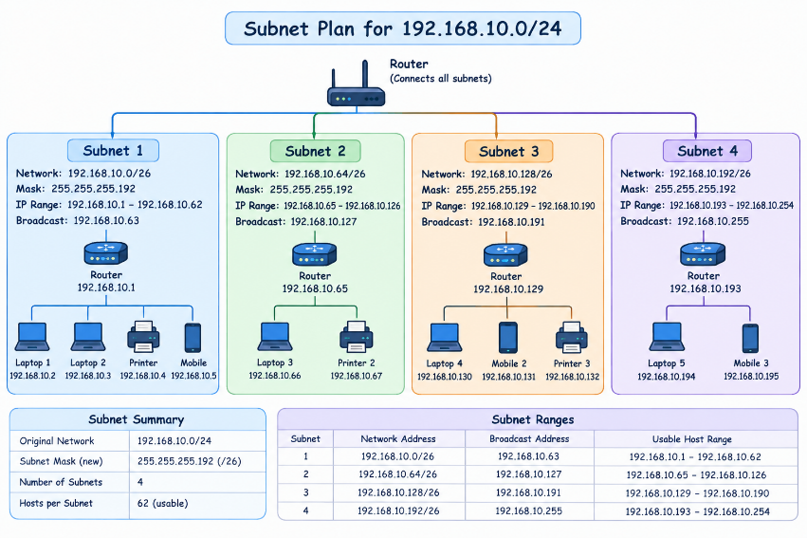
Document step-by-step how you calculated the subnet mask, number of hosts per subnet, and assigned IP addresses for your plan, as if you are explaining it to a friend who is new to subnetting.
Ans :
Step-by-Step Subnetting Calculation
Given Network
- Original Network: 192.168.10.0/24
- Required Subnets: 4
Step 1: Calculate the New Subnet Mask
The original network is /24.
We need 4 subnets.
To find how many bits to borrow:
2² = 4
So, we borrow 2 bits from the host portion.
New prefix:
/24 + 2 = /26
Therefore, the new subnet mask is:
/26 = 255.255.255.192

Step 2: Calculate Hosts Per Subnet
A /26 network leaves:
32 − 26 = 6 host bits
Total IP addresses:
2⁶ = 64 addresses
Two addresses cannot be assigned to devices:
- One is the network address
- One is the broadcast address
Therefore:
Usable hosts = 64 − 2 = 62 hosts
So, each subnet has 62 usable host addresses.

Step 3: Find the Block Size
The last octet of the subnet mask is 192.
Block size:
256 − 192 = 64
Therefore, the subnet addresses increase by 64:
0 → 64 → 128 → 192

Step 4: Create the Four Subnets
Subnet 1
- Network Address: 192.168.10.0
- Usable IPs: 192.168.10.1 – 192.168.10.62
- Broadcast Address: 192.168.10.63
Subnet 2
- Network Address: 192.168.10.64
- Usable IPs: 192.168.10.65 – 192.168.10.126
- Broadcast Address: 192.168.10.127
Subnet 3
- Network Address: 192.168.10.128
- Usable IPs: 192.168.10.129 – 192.168.10.190
- Broadcast Address: 192.168.10.191
Subnet 4
- Network Address: 192.168.10.192
- Usable IPs: 192.168.10.193 – 192.168.10.254
- Broadcast Address: 192.168.10.255
Step 5: Assign IP Addresses to Devices
I selected Subnet 1 for my devices.
Subnet 1 has the usable range 192.168.10.1 – 192.168.10.62.
Device | IP Address
Router | 192.168.10.1
Laptop 1 | 192.168.10.2
Laptop 2 | 192.168.10.3
Printer | 192.168.10.4
Mobile | 192.168.10.5
All these IP addresses are valid because they are inside the usable host range.
I did not assign:
- 192.168.10.0 → Network address
- 192.168.10.63 → Broadcast address
Final Summary
Original: 192.168.10.0/24
New Mask: /26 = 255.255.255.192
Number of Subnets: 4
Total Addresses per Subnet: 64
Usable Hosts per Subnet: 62
Block Size: 64
Easy Trick to Remember
For /26:
0 → 64 → 128 → 192
And every subnet follows:
Network → Usable Hosts → Broadcast
Example:
0 → 1–62 → 63

